**Inventory Accounting: (Gateway of tally picture)**

Inventory accounting is the valuation of inventoried goods that a business has not yet sold to its customers. The inventory of a business can include goods, raw materials and other products that the business buys, manufactures and stores to sell to its customers. The goods in the inventory are part of the assets of the organization. In a balance sheet report, businesses include their inventories as their current asset at the prices at which they purchased them. After they sell the inventory, the companies can remove its cost entry from the inventory account and make entries in the cost of goods sold and product revenue accounts. The profit-making ability of a business typically correlates with its inventory. Therefore, it's necessary to monitor it and keep it in balance.

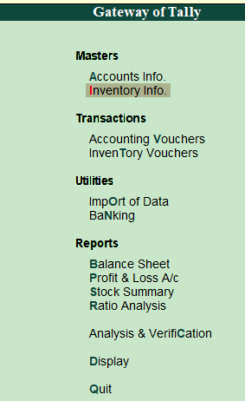

**Stock Groups:**

Stock Groups in Inventory are similar to Groups in Accounting. They are helpful in the classification of Stock Items. You can group Stock Items under different Stock Groups to reflect their classification based on some common features such as brand name, product type, quality, etc. Grouping enables you to locate the items easily and report their details in statements.

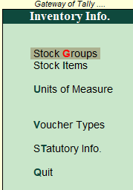 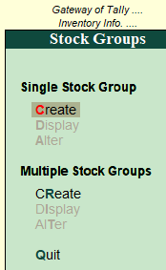 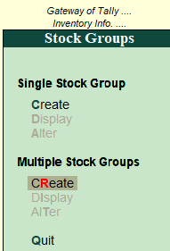

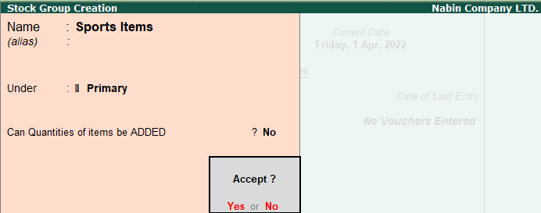

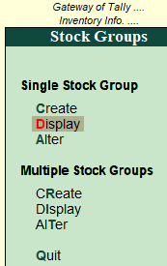 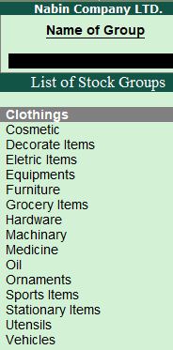

**Stock Group Creation:-**

* Go to **Gateway of Tally**.
* Click on **Inventory Info.**
* Click on **stock** **groups**.
* Then, create a stock group